**FUNCTIONAL AND NON FUNCTIONAL**

**FUNCTIONAL TESTINGS:**

1.Assertion testing

2.Gorilla testing

3.Sanity testing

4.Monkey testing

5.Smoke testing

6.Exploratory testing

7.Mutation testing

8.Benchmark testing

**ASSERTION TESTING:**

**Definition**:

An **assertion** is a **boolean expression**.it is a concept of **functional testing**. It is used to test a **logical expression**.

An assertion is true if the logical expression that is being tested is true and there are no bugs in the program. Assertion testing can be used at any particular stage of the program.

EX: 3<4=true, assertion true and logical expression true then their is no bugs.

7>10=false, assertion false and logical expression false then bugs are their.

**GORILLA TESTING:**

Gorilla testing is a software testing technique that repeatedly applies inputs on a module to ensure it is functioning correctly and that there are no bugs.

**SANITY TESTING:**

Sanity testing is performed on stable builds and it is also known as a variant of regression testing.

Sanity testing was performed when we are receiving software build (with minor code changes) from the development team. It is a checkpoint to assess if testing for the build can proceed or not.

In other words, we can say that sanity testing is performed to make sure that all the defects have been solved and no added issues come into the presence because of these modifications.

**MONKEY TSETING:**

Monkey Testing is a software testing technique in which the tester enters any random inputs into the software application without predefined test cases and checks the behavior of the software application, whether it crashes or not.

The purpose of Monkey testing is to find the bugs and errors in the software application using experimental techniques.

**SMOKE TESTING:**

Smoke Testing is a software testing process that determines whether the deployed software build is stable or not.

Smoke testing is a confirmation for QA team to proceed with further software testing. It consists of a minimal set of tests run on each build to test software functionalities.

Smoke testing is also known as “Build Verification Testing” or “Confidence Testing.”

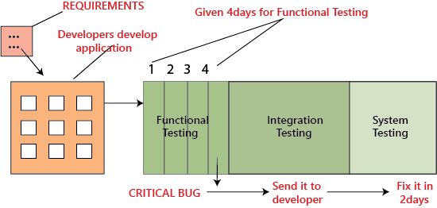

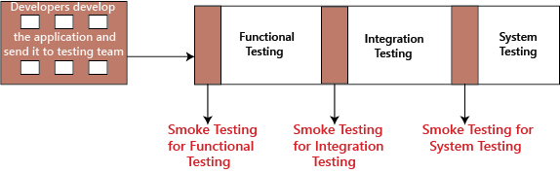

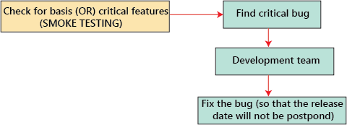

**EXPLORATOY TESTING:**

If requirement does not exist, then we do one round of exploratory testing.

So, for this first, we will be exploring the application in all possible ways, understanding the flow of the application, preparing a test document and then testing the application, this approach is known as exploratory testing.

**MUTATION TESTING:**

Mutation Testing is a type of software testing in which certain statements of the source code are changed/mutated to check if the test cases are able to find errors in source code.

The goal of Mutation Testing is ensuring the quality of test cases in terms of robustness that it should fail the mutated source code.

**BENCHMARK TESTING:**

A Benchmark in Performance Testing is a metric or a point of reference against which software products or services can be compared to assess the quality measures.

In other words, Benchmark means a set standard that helps to determine the quality of a software product or service.

the user experience cannot be quantified in numbers, but the time a user spends on a webpage due to good UI can be quantified.

Benchmark Testing is not a term related to just software testing, but it also deals with Hardware Testing

**NON-FUNCTIONAL TESTINGS:**

1.Load testing

2.Strees testing

3.Usability testing

4.Performance testing

5.Volume testing

6.Scalability testing

7.Security testing

**LOAD TSETING:**

Load Testing is a non-functional software testing process in which the performance of software application is tested under a specific expected load.

It determines how the software application behaves while being accessed by multiple users simultaneously.

The goal of Load Testing is to improve performance bottlenecks and to ensure stability and smooth functioning of software application before deployment.

**Load Testing Tools:**

1. Apache JMeter

2. Web Load

3. Neo Load

4. Load Ninja

5. HP Performance Tester

6. Load UI Pro

7. Load View

**STERRS TESTING:**

Stress testing (sometimes called torture testing) is a form of deliberately intense or thorough testing used to determine the stability of a given system, critical infrastructure or entity.

Stress testing involves testing the application under varying load. Extremely large numbers of concurrent users try to log into the application.

Database linked to the website shuts down when the website tries to reach it from the front end. Data in added in extremely large quantity in the database.

Stress Testing is a type of software testing that verifies stability & reliability of software application.

The goal of Stress testing is measuring software on its robustness and error handling capabilities under extremely heavy load conditions and ensuring that software doesn’t crash under crunch situations.

**USABILITY TSETING:**

Usability testing refers to evaluating a product or service by testing it with representative users. Typically, during a test, participants will try to complete typical tasks while observers watch, listen and takes notes.

to check the usability or ease of using a software product. Checking the user-friendliness, efficiency, and accuracy of the application is known as **Usability Testing.**

**Parameters:**

Efficiency

Memorability

Accuracy

Learnability

Satisfaction

Errors

**PERFORMANCE TESTING:**

Performance testing is in general a testing practice performed to determine how a system performs in terms of responsiveness and stability under a particular workload.

It can also serve to investigate, measure, validate or verify other quality attributes of the system, such as scalability, reliability and resource usage.

Types of Performance Testing:

• Load

• Stress

• Spike

• Endurance

• Scalability

• Volume

**VOLUME TESTING:**

Volume Testing is a type of software testing which is carried out to test a software application with a certain amount of data.

In volume testing a huge volume of data is acted upon the software. It is basically performed to analyze the performance of the system by increasing the volume of data in the database.

Volume testing is performed to study the impact on response time and behavior of the system when the volume of data is increased in the database.

Volume Testing is also known as Flood Testing.

**SCALABILITY TESTING:**

scalability testing, which comes under the non-functional testing of software testing.

It is used to check an application's performance by increasing or decreasing the load in particular scales known as scalability testing. It is executed at a hardware, software, or database level.

**SECURITY TESTING:**

The main goal of Security Testing is to identify the threats in the system and measure its potential vulnerabilities, so the threats can be encountered and the system does not stop functioning or can not be exploited.

It also helps in detecting all possible security risks in the system and helps developers to fix the problems through coding.

types of security Vulnerability Scanning. ...

Security Scanning. ...

Penetration Testing. ...

Security Audit/ Review. ...

Ethical Hacking. ...

Risk Assessment. ...

Posture Assessment. ...

Authentication.

**Soak Testing** is a type of performance testing where the software under load is tested to validate that it can endure heavy loads for the extended period.

**Soak Testing** is a type of software testing in which system is tested under huge load over a continuous availability period to check the behavior of the system under production use.   
Soak Testing tests that system can withstand a huge volume of the load for an extended period of time.

This testing is performed at the system level to find whether the system will stand up to a very high volume of usage or not. It also tests that what would happen outside the design expectations of the system.

**Objective of Soak Testing:**   
The objective of Soak Testing is to:

* To check the system behavior under heavy load for long time.
* To predict the failure caused by the heavy load.
* To test the performance of the system.
* To make the system reliable and stable.

**Failures detected by Soak Testing:**   
The failures or issues detected by the Soak Testing are:

* **Memory Leaks:**   
  Soak testing detects the serious memory leaks which can cause application crash or lead up to the crash of operating system.
* **Layer Connections Failure:**   
  Soak testing finds the failure of close connections between the layers of the system that can interrupt the modules of the system.
* **Database Connections Failure:**   
  Soak testing detects the failure of close database connections under some conditions that may crash the complete system.
* **Response Time Degradation:**   
  Soak testing finds the degradation of response time of the system as the system becomes less efficient and takes more time to response.

**Soak Testing Graphical Representation:**

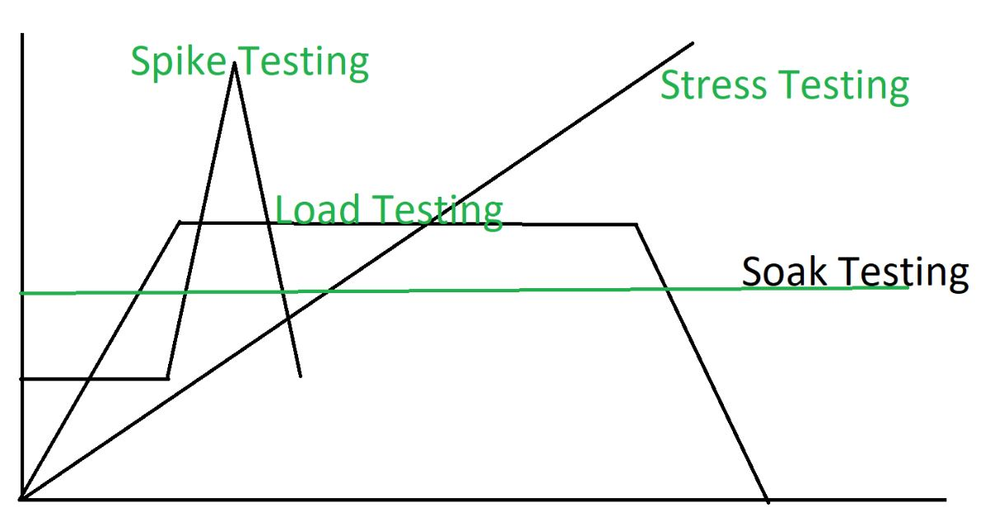

**Advantages of Soak Testing:** The advantages of Soak Testing are:

* Soak Testing improves the performance of the system.
* Soak Testing increases the resistance of the system.
* Soak Testing makes the system work under heavy load.
* It improves the behavior of the system under the heavy load for long time.

**Disadvantages of Soak Testing:**

* It is difficult to know or predict how long that the test will run.
* Utilization of the memory is high due to more number of users accessing the web application.
* It is a time consumption process and it is not recommended for the project which has strict deadlines.
* Manual soak testing often takes lot of time to complete the test and often provides wrong test results.
* If we run this technique in a live environment then it will lead to loss of data or data corruption.

**Spike testing** is **a type of performance testing in which an application receives a sudden and extreme increase or decrease in load**. The goal of spike testing is to determine the behavior of a software application when it receives extreme variations in traffic.

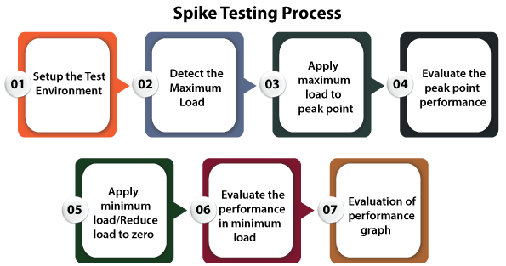

**Connection testing:**

An internet speed test **measures the connection speed and quality of your connected device to the internet**. It does so by running multiple consecutive tests that analyze different aspects of your internet connection, namely ping (latency), download speed, and upload speed.

**Production testing**

Testing in production, rather, refers to **the continuous testing of the application in the production environment, after a deployment**.